**Name of SENDCo**: Caroline Dinham **Dedicated time:** 1.5 days - weekly

**Contact email:** [senco@lanner.cornwall.sch.uk](mailto:senco@lanner.cornwall.sch.uk)

**Contact phone number:** 01209 216345

**SEND Governor:** Nicola Sheldon

**School Offer link:**

See website.

**Whole School Approach to Teaching and Learning**

Lanner School has a whole school approach to teaching and learning which is met in the following ways:

* Quality first teaching and learning - all teachers are responsible for the learning and progress of every child in their class, including those with SEND.
* An inclusive, differentiated and personalised approach to enable all learners, including those with SEND, to engage with all aspects of school life.
* A robust teaching and learning policy in place.

**The Graduated Response at Lanner Primary School is structured in the following manner.**

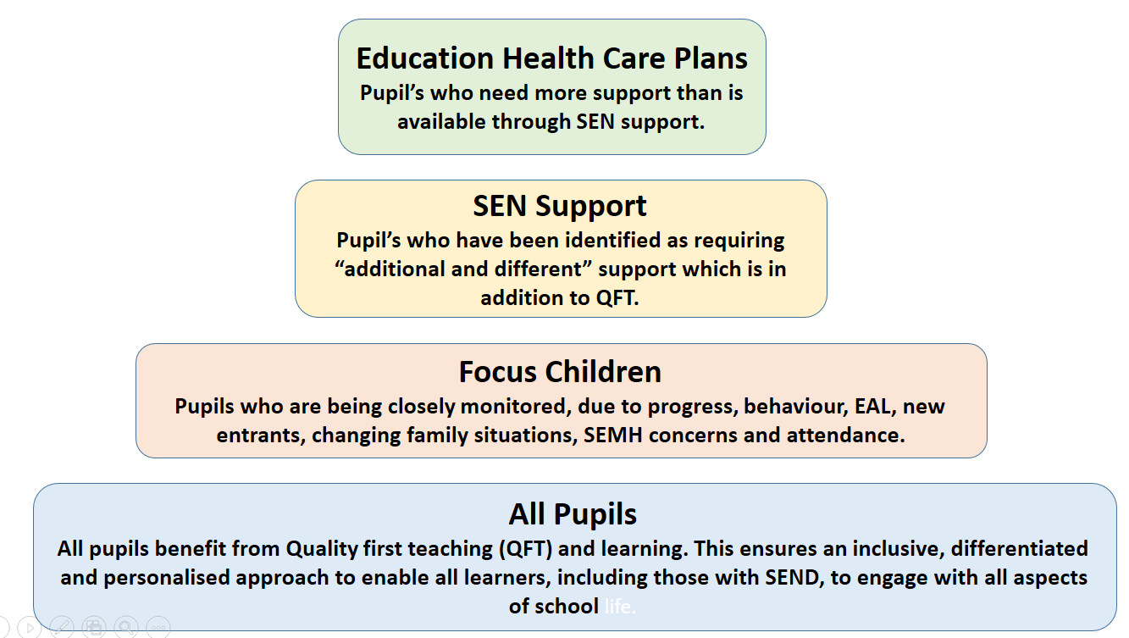

**We implement the Graduated Response in the following ways.**

* Consistent monitoring of the quality of teaching, to ensure that we are delivering an inclusive, differentiated and personalised approach to enable all learners, including those with SEND, to engage with all aspects of school life.
* Identifying and tracking the progress of children / young people that require support, removing barriers to learning by putting effective support in place.
* We take immediate action when pupil’s are identified as having Special Educational Needs (SEN). We also inform the pupil’s family as soon as SEN is identified. Children / young people requiring “additional and different” support are part of our ‘Assess, Plan, Do, Review’ (APDR) cycle and are classified as SEN Support.

The APDR cycle takes the form of termly outcomes and targets linked to the specific special educational needs of the pupil. We work in partnership with the pupil, their parents and carers, including them in decision making process.

All parties are also involved in the ongoing APDR review cycle, with reviews being conducted on a termly basis. Review cycles are used to inform changes to a child or young person's SEN support.

* When necessary, we apply for Education, Health and Care Plans.
* All children / young people identified as requiring SEN Support, or with an Education, Health and Care Plan (EHCP) or statement are on the school Record of Need.
* We seek and gain advice from specialist professionals whenever necessary.

**How we identify children / young people that need additional or different provision.**

* Referral from Class Teacher to SENDCo
* Referral to the Learning Support Mentor
* Parental concerns / referrals
* Ongoing curriculum assessments (summative every half-term)
* Tracking pupil progress using data
* Further assessments by specialists, including those from external agencies

**Lanner Primary School**

We take a holistic approach in all aspects of a child’s development and well-being. Our pastoral support arrangements for supporting the emotional and social development of all children / young people, including those with SEN, are set out in our School Offer. Our measures to prevent bullying can be seen in our anti-bullying policy.

**How we listen to the views of children / young people and their parents:**

|  |  |  |
| --- | --- | --- |
| **What** | **Who** | **When** |
| Informal discussions | Class teachers  Head teacher  Pastoral Mentor  SENCo | On Going  On going  As required  On going |
| Parents Evenings | Class teachers  SENCo | Autumn |
| Reports | Class teachers | Spring  End of Summer Term – attainment data only |
| Reading Records | Class TAs / Teachers | Daily |
| Home / school books | Class teachers | When required for individual children. |
| Dojo and SeeSaw | Class teachers | On going |
| Assess, Plan, Do review meetings / TAC meetings  EHCP Reviews | SENCo / Class teachers | Termly  As required |
| Senco / Parent meetings | Senco and all parents | On request |
| Questionnaires | All pupils and parents. | Annually. |
| School Council | Head teacher | Fortnightly – when Covid considerations allow. |
| Pupil conferencing | SENCo / Class teachers  Head teacher | Termly |
| Parent referrals | SENCo / Class teachers  Head teacher  Pastoral Mentor | As required |

**The ‘Assess, Plan, Do, Review’ cycle:**

For SEN Support children and children in receipt of an EHCP, an Assess, Plan, Do, Review (APDR) cycle will be established by the SENCo in partnership with the child / young person, their parents and the class teacher. Please see SEN Policy for further details.

This year, the provision made for children / young people on our Record of Need has been:

**Communication and Interaction**

Children who are a cause for concern in this area are referred to the Speech and Language Therapy Service. When Covid restrictions allowed, the Community Speech and Language Therapist visited children on a termly basis to assess individual children, review and set new targets, monitor provision and advise staff.

Each child with an identified speech, language and communication need works with a Teaching Assistant on specific targets as advised by the Speech and Language Therapist. All adults working with the child are made aware of the targets to develop in class. Classrooms are also monitored to ensure that they are communication friendly.

In addition to this, the school accesses support to inform provision and offer advice and strategies when working with children with ASDs. Where children are suspected to have an ASD, referrals are made to the Children’s Neurodevelopmental Assessment Service (including ASDAT).

**Cognition and Learning**

Children causing concern in this area may require further assessment to identify learning needs, for example, if dyslexia is a concern, a Dyslexia Screening Test (DST) will be carried out and the results used to inform further provision. Where progress is a concern, or interventions have made little, or no impact, a referral many be made to the Educational Psychologist or the Cognition and Learning Team.

Children requiring additional support to catch up, have accessed the following support: Phonological Awareness intervention, Read, Write Inc - Fresh Start and small group booster groups, pre and post teach, comprehension support through Read Theory, Toe by Toe, SNIP Dyslexia Program, taught comprehension intervention groups, Dyslexia Gold online support, Number Sense Intervention program and Timestable Rock stars

**Social, Emotional and Mental Health**

The school has TIZ trained class practitioners to support children with their emotional literacy; this may be in small groups, or on a 1:1 basis. In addition to this, children may be referred to the school’s Pastoral Mentor. Referrals have also been made to external agencies e.g. CAMHS for further assessment and support.

**Sensory and/or Physical Needs**

Where children are diagnosed with a sensory processing need, advice is taken from the Occupational Therapist and care plans followed. Occupational Therapy and Physiotherapy referrals are made for children who require further assessment.

When Covid restrictions allow, Funfit is provided for those that need extra support with gross motor skills.

Our Record of Need fluctuates throughout the academic year and by the end of the 2020/2021 academic year, there were 27 children receiving SEN support, with an additional 6 children with Education, Health and Care Plans.

The needs of these children on the Record of Need for 2022/2023 are broken down as follows:

|  |  |  |  |  |  |  |  |  |
| --- | --- | --- | --- | --- | --- | --- | --- | --- |
| Area of need | EYFS | Y1 | Y2 | Y3 | Y4 | Y5 | Y6 | Total |
| Communication and Interaction | 3 | 1 | 2 | 1 |  | 2 | 2 |  |
| Cognition and Learning | 1 | 1 | 1 | 2 |  | 4 | 3 |  |
| Social, Emotional and Mental Health |  | 1 |  | 1 | 4 |  | 3 |  |
| Sensory and Physical |  |  | 1 |  |  |  |  |  |
| Total | 4 | 3 | 4 | 4 | 4 | 6 | 8 | 33 |

Quality of provision is monitored by learning walks, pupil conferencing, assessment, book looks and feedback from parents and carers. This information is supplemented by advice provided by outside agency and in class support from speech and language and occupational therapy supervision.

**Support Staff Deployment**

Support staff are deployed in a number of roles:

* Classroom TAs
* Group Intervention such as Pre and Post Teaching, SNIP Dyslexia Program, Phonological Awareness.
* 1:1 to meet the learning needs of children with Statement / EHCP / Social, Emotional and Behavioural Needs
* 1:1 to deliver speech and language programs (advised by the Speech and Language Therapist)
* 1:1 support Learning Mentor
* Sensory / physio / OT / medical plans when required.

Quality and Impact of provision is monitored by data analysis, supervision meetings, pupil conferencing and discussion with parents.

**Distribution of Funds for SEN:**

During the year 2022-23 the budget for SEN and Inclusion was £ 7,566

This was allocated in the following ways:

* Support staff
* Learning Mentors
* External Services (see school’s Local Offer)
* Teaching and Learning Resources
* Staff training

**Continuing Development of Staff Skills**

|  |  |  |
| --- | --- | --- |
| **Area of Knowledge / Skill** | **Staff Member** | **Training Received** |
| Pastoral / Well Being | Learning Mentor  All TAs | TIS training  Mind Ed Training |
| Safeguarding | Headteacher  DSLs | Safer recruitment  Child Protection Level 3 |
|  | All Staff  SENCO | Child Protection  Prevent |
| Behaviour Management | Teamteach – JP, CD, KW, | De-escalation through Teamteach |
| SEMH Management | All staff  SENCO | Emotion Coaching  TISUK Whole School  Mental Health Lead Training – Creative Education. |
| Acute Allergy | Named TAs and Teachers | Epi-Pen Training |
| Medical | Named TAs and Teachers | Diabetes Training  First Aid including Paediatric First Aid |
| Well being | Named TAs and Teachers | First Aid at Work  Paediatric First Aid |
| Curriculum Delivery – Quality First Teaching | Named TAs and Teachers | Daniel Sobel - Pupil Premium - removing barriers and meeting the needs of students  WhiteRose Maths - Managing the return to school  Guy Claxton Training  Phonological Awareness  Effective questioning to  support reading  Read Write Ink  Maths Hub |
| English  Maths |
| Individual Needs | Teachers | Staff surgeries with EP |

Training needs are identified by completing an audit of staff skills alongside an audit of the need of the children - identified by the provision they need to access.

**Partnerships with other settings and how we manage transition**

Lanner has worked with a number of settings and schools in the area in the following ways:

* SENDCo partnership with other schools (including schools within the Crofty Multi-Academy Trust)
* Transition into Lanner Primary from other mainstream schools.
* Planning meetings with nurseries to support transition into our EYFS
* Planning meetings with secondary settings for transition (including extended transition for those pupils needing it.
* Transition from class to class within the school.

We ensure that transition between nurseries to EYFS is smooth by having planned transition meetings in the summer term.

Transition meeting were also held remotely with other nursery settings, in order to gather information and smooth the transition to nursery or reception.

The transition from Year 6 to senior schools was supported through meetings and discussions between the Year 6 teacher, SENCO and the SENCo at the secondary schools in question. Enhanced transition was required for a small group of children, this comprised of additional information being provided by ourselves, supplemented by parent and pupil visits to the school in question.

This year transition from one class took the form of “move up day”, with pupils spending time in their new classroom with their new teacher and classroom assistant.

**Ongoing development:**

We work hard to ensure that any areas of support for our learners that can be improved are identified and that strategies are put in place to make those improvements. We do this through our School Development Plan, this can be found on our school website.

**Our Complaints Procedure:**

Anyone wishing to make a complaint with regard to SEN support and provision should inform the Headteacher and SENCo via the school office.

This year we received 0complaints with regard to SEN support and provision.

**Other relevant information and documents:**

The Designated Safeguarding Lead in our school is Claire Merrifield.

Our Deputy Safeguarding Leads are Kieran Walsh and Jayne Pascoe. Our Safeguarding Governor is Emily Cromey.

The Designated Children in Care person in our school is Claire Merrifield.

The Local Authority’s Offer can be found at [www.cornwallfisdirectory.org.uk](http://www.cornwallfisdirectory.org.uk)

Our Accessibility Plan can be found on our website

The School Development plan can be found on our website.

Our SEN Policy and School Local Offer (our contribution to the Local Offer) can be accessed via the links on our website.

Our SEN Policy, School Offer and Information Report have been written in accordance with the Disability Discrimination Act 1995, the Equality Act 2010 and the Children and Families Act 2014.