YEAR 4 | Autumn 1 | Autumn 2 | Spring 1 | Spring 2 | Summer 1 | Summer 2
Reading  Fiction | Historical  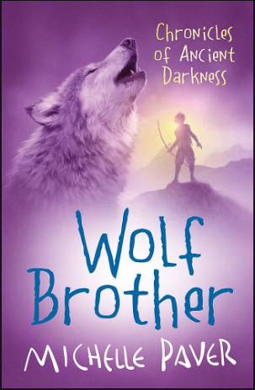  Wolf Brother  by Michelle Paver  4.5 | Quest  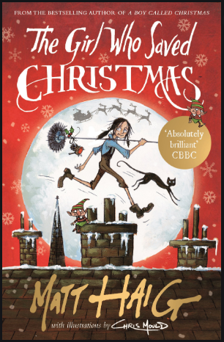  The Girl Who Saved Christmas by Matt Haig  AR 4.6 | Adventure  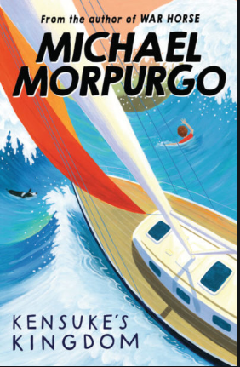  Kensuke’s Kingdom  by Michael Morpurgo  AR 4.7 | Modern Classic  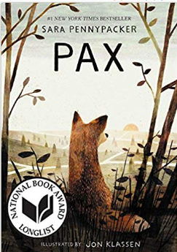  Pax by  Sara Pennypacker  AR 5.3 | Historical  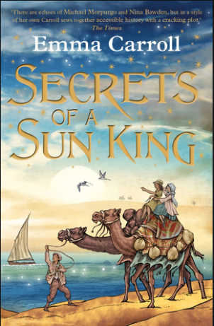  Secrets of a Sun King  by Emma Carroll  AR 5.0 | Adventure  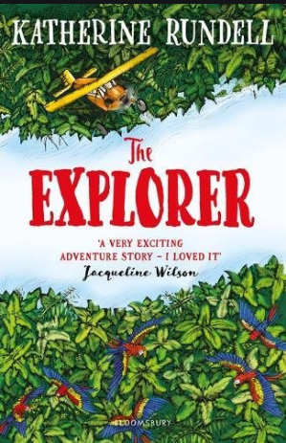  The Explorer by Katherine Rundell  AR 4.5
Non-fiction | 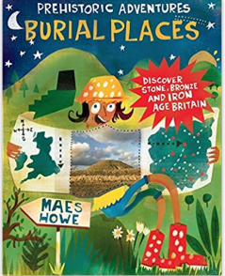  Burial Places  by John Malam | 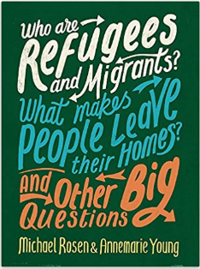  Who are Refugees and Migrants? By Michael Rosen and Annemarie Young | 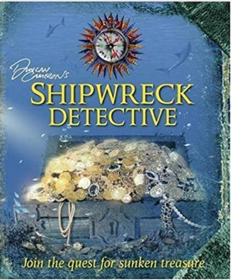  Shipwreck Detective  by Richard Platt | 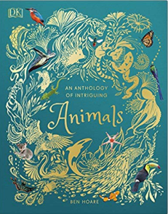  An Anthology of Intriguing Animals  by Ben Hoare | 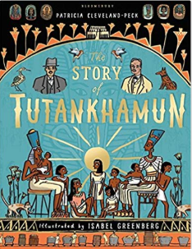  The Story of Tutankhamun by  Patricia Cleveland-Peck | 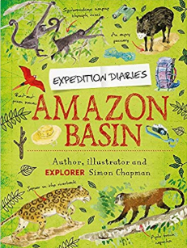  Amazon Basin  by Simon Chapman
English | Narrative: building suspense.  Explanation: How people survived the Stone Age. | Narrative: Character descriptions from `The Girl who saved Christmas`  Persuasive writing: letter ask for Samaritan`s Purse donations  Newspaper reports on events from `The Girl who saved Christmas` | Narrative – Ship’s Log and Shipwreck diary  Instructions: How to survive on a desert island. | Narrative- North American Animal adventure  Balanced argument: Are foxes pests? | Biography: Howard Carter / Tutankhamun.  Narrative: Egyptian Myth (How was the desert created?)  Explanation: How Ancient Egyptians mummified their dead. | Character and setting descriptions  Narrative- missing chapter ( alternative ending with own Amazonian tribe character  Non-chronogical report: rainforest creatures.  Persuasive leaflet: Save the rainforest
Poetry | Black History month- poem from another culture | Narrative poetry:  Benjamin Zephaniah, ‘We refugees’. | Poetry – Haiku  (Lit Shed Plus) | Forest animal riddles | Classic poetry | Rhyming couplets- rainforest layers
Cross curricular writing. | Persuasive write: who was more advanced, the Celts or the Mayans? | Instructions: How to be a Hindu God | Explanation: How does the Water Cycle Work? | Haiku poem: Foxes | Diary: Howard Carter’s Diary | Newspaper report: Deforestation
Maths | Number: Place Value  Number: Addition and Subtraction  Measurement: Area  Number: Multiplication and Division |  | Number: Multiplication and Division  Measurement: Length and perimeter.  Number: Fractions  Number: Decimals |  | Number: Decimals  Measurement: Money  Measurement: Time  Statistics  Geometry: Properties of Shape; Position and Direction
Applied maths | Number line work linked to chronology (History) | Written addition of multiple numbers - route for Santa, adding several distances in miles (Geography)  Written addition - keeping a running total of cost of Shoe box gifts as they buy online  Venn diagrams (Science) | Number line work linked to chronology and dates (History)  Statistics - collecting weather data (Computing)  Interpreting data- water cycle- Science | Number- comparing 4 digit numbers-lengths of rivers (Geography)  Geometry- tessellations in computing  Measure, reading scales for food project (DT) | Egyptian pyramids- shape and area (DT) | Reading continuous line graphs - temperature and rainfall in Amazon Rainforest (Geography)  Measure in DT, levers and linkages
Science | Animals including humans: digestive system and teeth. | Electricity | States of Matter  Water Cycle | Animals, including humans: food chains. | Sound | Living Things and Habitats
Book-led Science | Explore: What evidence is there for dental health in the Iron Age? |  |  | Explore: What is the food chain of a fox? |  | Explore: How are rainforests changing and what dangers does this pose to wildlife?
History | Changes in Britain from the Stone Age to the Iron Age. |  | Local History – Wreck and Rescue – a study of local shipwrecks through time. |  | The Achievements of the Earliest Civilisations – Egyptians.
Book-led history | Explore: When was the story set? How was life different then? | Explore: When was the story set? What clues are there? What was life like for children then? |  |  | Explore: Who was Howard Carter and why was he important?
Geography |  | Settlements: who are immigrants and refugees?  What is it like in the UK? |  | What is a river? Where are the key rivers of the world? Why are they so important? |  | Forest biomes including rainforests. Focus on Amazon Rainforest.
Book-led Geography |  | UK cities –create a route for Santa. | Explore: Where did Michael travel? Plot a route on a map. | Where is the story set? What are the geographical features of the area? How is it similar / different to our area? | Where is Egypt? What is it like there? Why did people settle by the Nile? How is it similar / different to the UK? | Explore: Where in the world is the story set? How is it similar / different to the UK? (Geographical features / climate)
Art | Sculpture: willow sculptures. Study of artist Emma Walker |  | Drawing: Pencil, Pen and ink and pastel  Study of Artist: Hokusai |  | Painting and photography: Egyptian style portraits  Study of artist: Klimt
DT |  | Textiles: Christmas Stockings | Electrical: Lighthouse with circuit. | Food: Native American Meal |  | Mechanisms: levers and linkages - moving rainforest animals
RE | What is the ‘Trinity’ and why is it important to Christians? | What do Hindus believe that God is like? | What does it mean to be a Hindu in Britain today? | Why do Christians call the day that Jesus died ‘Good Friday’? | For Christians, when Jesus left, what was the impact of Pentecost? | Curriculum Kernewek: How and why do people in Cornwall mark significant events in community life?
Computing | Gooseberry Planet: digital footprint  RS Switched on Computing  We are software developers (Unit 4.1) | Gooseberry Planet: clickjacking  RS Switched on Computing  We are makers (Unit 4.2) | Gooseberry Planet: webcam wise  RS Switched on Computing  We are meteorologists (Unit 4.6) | Gooseberry Planet: sharing safely  RS Switched on Computing  We are artists (Unit 4.5) | Gooseberry Planet: online gaming  RS Switched on Computing  We are bloggers ( Unit 4.4) | Gooseberry Planet: boundaries and illegal downloads  RS Switched on Computing  We are musicians(Unit 4.3)
PE | 4.5 Nimble Nets | 4.1 Invaders | 4.3 Gym Sequences | 4.2 Dynamic Dance | 4.3 Step to the beat | 4.6 Young Olympians
 | 4.5 Cool Core (Pilates) | 4.1 Boot Camp | 4.4 Striking and Fielding | 4.2 Mighty Movers (Boxercise) | 4.4 Gymfit Circuits | 4.6 Fitness Frenzy
PSHE | Lifewise  Healthy Eating and a balanced diet  The importance of physical activity  Relaxing to Recharge  The recreational drugs of alcohol and nicotine | Lifewise  Sleep  Screen time  Autism: Aspergers  What’s love? | Lifewise  Bullying  Everything will be alright  All about Tik Tok  Identity and gender  Fairtrade: Change through choice | Lifewise  BV government and rules  BV freedom and beliefs  Family relationships | Lifewise  Consent  Where does my food come from?  Respect  Being responsible  Earning money | Lifewise  Problem solving and resourcefulness  Try and tray again  Leadership  Keeping my body safe (Taught in Health and Sports week)
Music | Charanga: Mamma Mia | Glockenspiel stage 2 | Stop! | Lean on me | Blackbird | Reflect, rewind and replay
MFL | Unit 4: Les animaux  Animals and pets  Numbers to 20  Use third person (he/she) for names and description | Unit 6: Bon anniversaire!  Food: ask for snacks;  Numbers to 31;  Months;  Form dates: It is | Unit 7: Encore!  Revise ways of describing people.  Nationalities. | Unit 8: Quelle heure est-il?  Tell the time.  Talk about activities and times. | Unit 9: Les fêtes  Festivals and dates.  Describe gifts.  Numbers 31 – 60.  Give/understand instructions. | Unit 10: Unit 10: Où vas-tu?  name and recognise various French cities  • give and understand basic directions  • talk about the weather  • talk about the weather in a particular city
Experiences | Visit to Carn Euny | Buy something in a shop.  Perform acts of kindness – Shoe boxes. |  | Feadon Farm- meet the animals | Visit a museum (RCM _ Egyptian experience)

